* **Using the Criteria**

More flexible solution

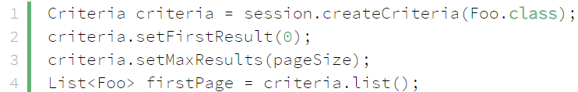

*Query*

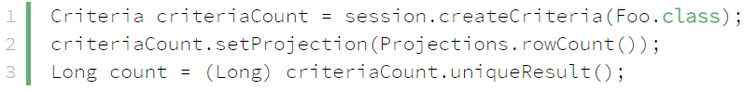

*Get total count*

* **Reference**

<https://www.baeldung.com/hibernate-pagination>